Assignment 2:
Badshah Jan (2280175)
BSSE-7B
LAB 9b:
TASK1:
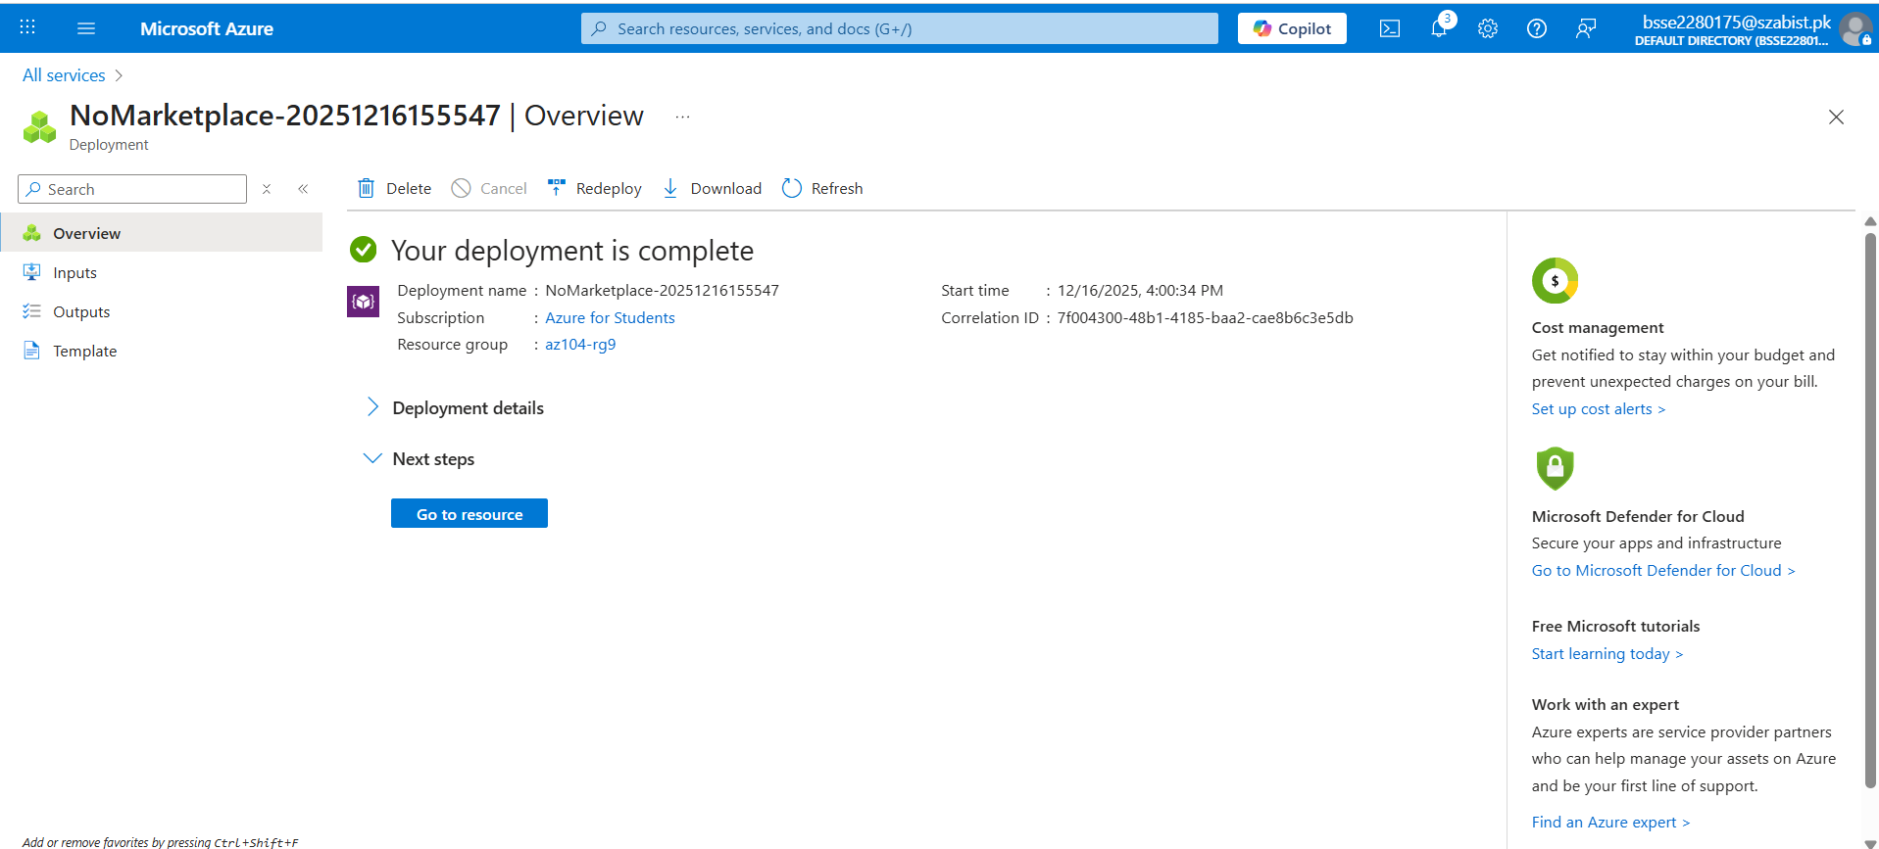
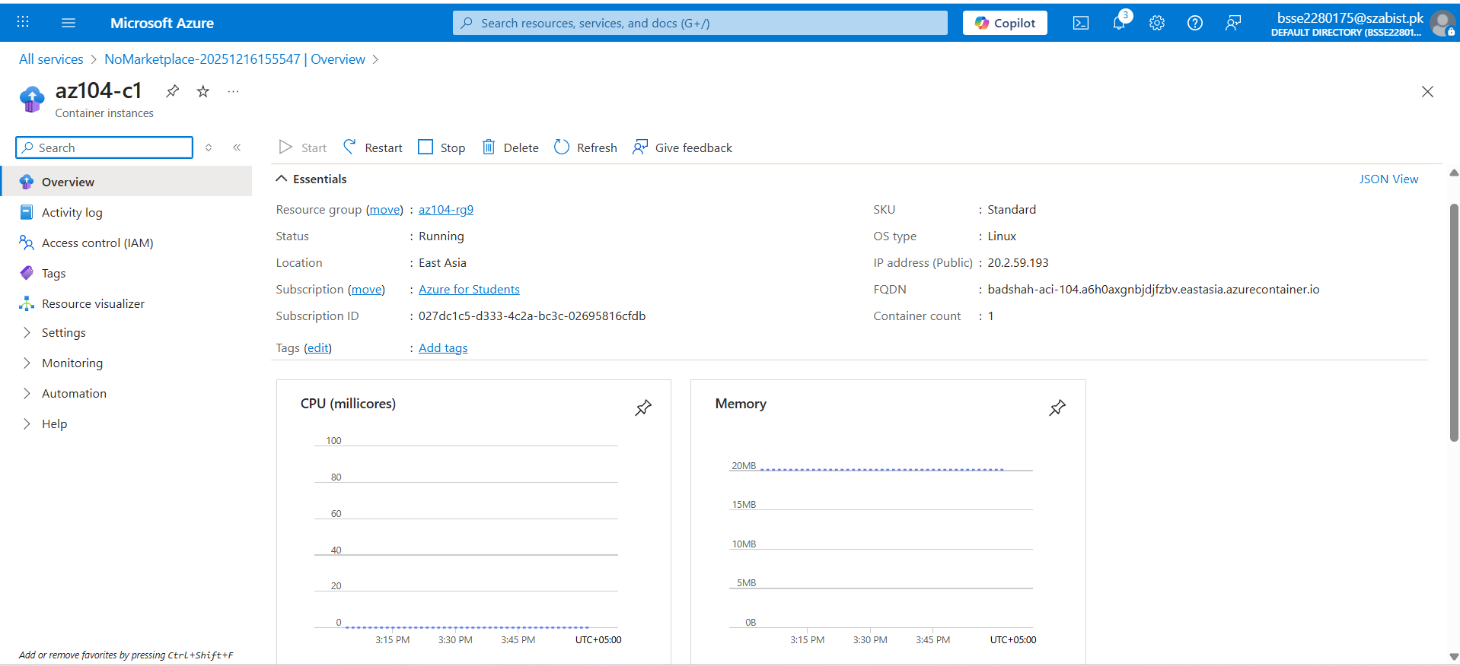

TASK2:
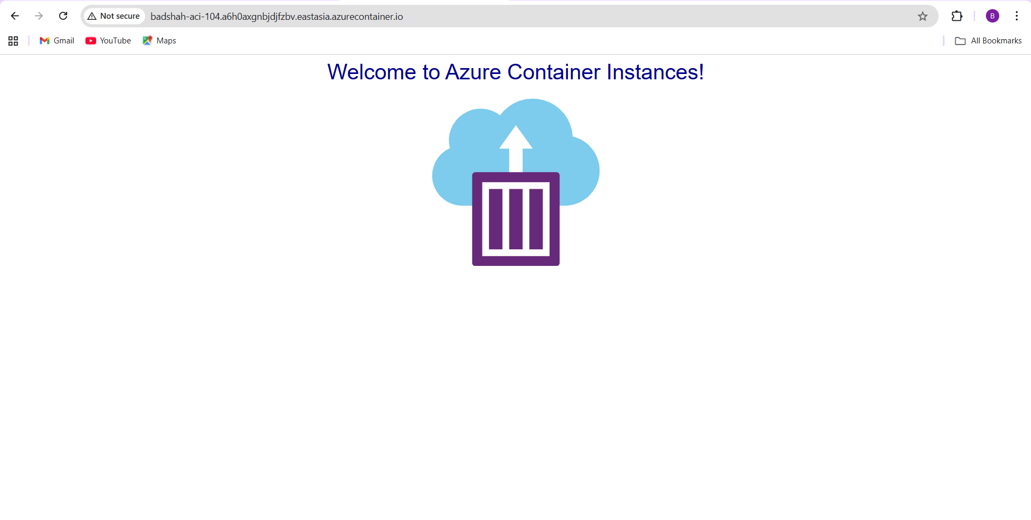
listening on port 80
::ffff:10.92.0.11 - - [16/Dec/2025:11:04:28 +0000] "GET / HTTP/1.1" 200 1696 "-" "Mozilla/5.0 (Windows NT 10.0; Win64; x64) AppleWebKit/537.36 (KHTML, like Gecko) Chrome/142.0.0.0 Safari/537.36"
::ffff:10.92.0.11 - - [16/Dec/2025:11:04:29 +0000] "GET /favicon.ico HTTP/1.1" 404 150 "http://badshah-aci-104.a6h0axgnbjdjfzbv.eastasia.azurecontainer.io/" "Mozilla/5.0 (Windows NT 10.0; Win64; x64) AppleWebKit/537.36 (KHTML, like Gecko) Chrome/142.0.0.0 Safari/537.36"
::ffff:10.92.0.11 - - [16/Dec/2025:11:05:44 +0000] "GET / HTTP/1.1" 304 - "-" "Mozilla/5.0 (Windows NT 10.0; Win64; x64) AppleWebKit/537.36 (KHTML, like Gecko) Chrome/142.0.0.0 Safari/537.36"
::ffff:10.92.0.11 - - [16/Dec/2025:11:05:44 +0000] "GET / HTTP/1.1" 304 - "-" "Mozilla/5.0 (Windows NT 10.0; Win64; x64) AppleWebKit/537.36 (KHTML, like Gecko) Chrome/142.0.0.0 Safari/537.36"
::ffff:10.92.0.11 - - [16/Dec/2025:11:05:45 +0000] "GET / HTTP/1.1" 304 - "-" "Mozilla/5.0 (Windows NT 10.0; Win64; x64) AppleWebKit/537.36 (KHTML, like Gecko) Chrome/142.0.0.0 Safari/537.36"
::ffff:10.92.0.11 - - [16/Dec/2025:11:05:45 +0000] "GET / HTTP/1.1" 304 - "-" "Mozilla/5.0 (Windows NT 10.0; Win64; x64) AppleWebKit/537.36 (KHTML, like Gecko) Chrome/142.0.0.0 Safari/537.36"
::ffff:10.92.0.11 - - [16/Dec/2025:11:05:46 +0000] "GET / HTTP/1.1" 304 - "-" "Mozilla/5.0 (Windows NT 10.0; Win64; x64) AppleWebKit/537.36 (KHTML, like Gecko) Chrome/142.0.0.0 Safari/537.36"
::ffff:10.92.0.9 - - [16/Dec/2025:11:05:46 +0000] "GET / HTTP/1.1" 200 1696 "-" "Mozilla/5.0 (Windows NT 10.0; Win64; x64) AppleWebKit/537.36 (KHTML, like Gecko) Chrome/142.0.0.0 Safari/537.36"
::ffff:10.92.0.9 - - [16/Dec/2025:11:05:46 +0000] "GET / HTTP/1.1" 304 - "-" "Mozilla/5.0 (Windows NT 10.0; Win64; x64) AppleWebKit/537.36 (KHTML, like Gecko) Chrome/142.0.0.0 Safari/537.36"

